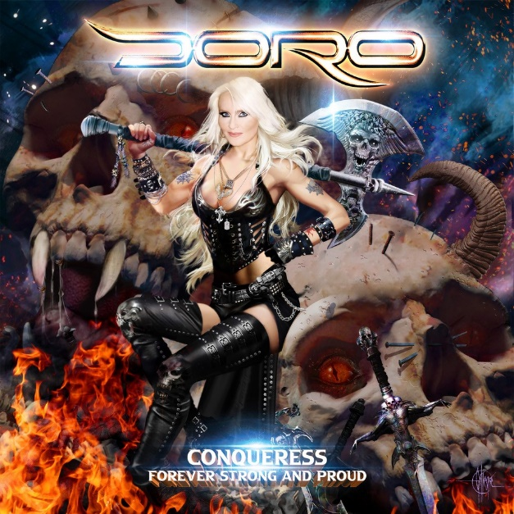
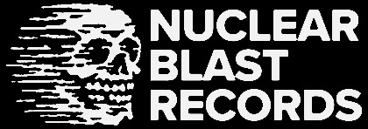

DORO

Conqueress- Forever Strong and Proud

Release Date: October 27th 2023

Line up: | DORO online:
Doro Pesch – Lead Vocals | www.doro.us  www.doromusic.com  www.instagram.com/dorometalqueen  www.facebook.com/DoroPeschOfficial  www.patreon.com/doropesch  www.tiktok.com/@doropeschofficial  www.twitter.com/DoroOfficial
Respected. Iconic. Undisputed. DORO is the Metal Queen.

Emerging from the explosion of heavy metal that began in the early ‘80s, Doro Pesch has been tireless in her devotion to the metal cause for four decades. In 2023, she celebrates 40 years of active service, with two special anniversary live shows and, most importantly, a brand-new studio album that looks certain to be regarded as one of her best.

DORO’s campaign of heavy metal heroism began in earnest back in 1983, with the recording of Burning The Witches, the debut album by WARLOCK. Still in her teens, DORO was immediately recognisable as the consummate metal frontwoman, with a powerhouse voice and endless charisma. Plus, the music she made kicked a ridiculous amount of ass. DORO’s big breakthrough came in August 1986 when WARLOCK performed at the Monsters Of Rock festival at Castle Donington, with SCORPIONS, MOTÖRHEAD, DEF LEPPARD and OZZY OSBOURNE also appearing. The first woman to perform on the Monsters Of Rock stage, she sealed her iconic status at that very moment, and has never looked back since.

“We played Monsters Of Rock and then people started giving us a chance, so we went on tour with Judas Priest, and then afterwards it was just like a dream. I moved to New York in ‘86/’87 and we did the Triumph & Agony album, which became a big success. I still love to play all those songs, they’re always in our set list. Then we toured with DIO, who I admired so much. Then we did a big, long tour with MEGADETH in the States. The videos were on MTV and Headbanger’s Ball, and I miss that so much! TV was super important. I had the chance to host Headbanger’s Ball too! I loved it all. It was a total highlight in my life.”

Like many big metal artists, DORO had to negotiate changing times in the ‘90s, when grunge became the sound of the decade and traditional metal experienced a downturn in fortunes. Once again proving her commitment to the music she loves, DORO forged ahead with albums that toyed with newer styles of heaviness, without sacrificing any of the power and passion that made her so successful in the first place. From 1990’s DORO, produced by KISS legend Gene Simmons, to the soulful True At Heart and Angels Never Die and the even industrial influenced 1998 record Love Me In Black, she weathered the storm with style and grace. When heavy metal came roaring back in the 21st century, DORO was ready and prepared to reclaim her throne, armed with 2000’s true metal bonanza Calling The Wild. Demonstrating a relentless work ethic, she has spent the last 20 years releasing further thunderous, anthem-packed records like Fight, Fear No Evil and Raise Your Fist, delighting and thrilling her international fan base in the process.

In 2022, she was awarded the Lifetime Achievement Award, having already received an Echo, the Metal Goddess Legend Award in Las Vegas, the Legend Award in England and Germany, the Angel Of Rock Award in England and awards as the “sexiest woman alive”, among others. She has also been voted Best Female Vocalist in Spain for 30 years in a row, and was inducted into the Hall Of Heavy Metal History in the United States. Thanks to an unwavering work ethic and dedication to the metal cause, DORO has performed over 3,000 concerts in more than 60 countries.

“I thought we might last for five years when I first started in Warlock,” says DORO. “But I could always count on the fans, even during difficult times. In the ‘90s when grunge was big, we could still do it, we could still tour. That was my strength and my rock, the fan base worldwide. I think it goes both ways. I love the fans with all my heart and I feel they’d do anything for me. The music is a great vehicle to keep connected, and the live shows just get better and better.”

In 2018, DORO released Forever Warriors, Forever United, a colossal, two-album extravaganza that loudly proclaimed the Metal Queen’s greatness from the rooftops. Five years later, she has completed work on the follow-up. Due for release later in 2023, the new album bears a title that neatly sums up DORO’s unique reputation: Conqueress - Forever Strong and Proud.

“At first it was going to just be called Forever Strong & Proud. But then I thought it maybe needed something more, because we’ve conquered the world!“ DORO laughs. “Conqueress sounds more powerful. It’s the female form of conqueror, and I thought that was cool. I’ve always loved the word conquistador, for the same reasons. I had a lot of ideas for a title floating around, and then in the last two weeks I made up my mind, which drives everybody crazy because it’s always so last minute! [Laughs]”

A tour-de-force of melodic metal and high-octane hard rock, Conqueress – Forever Strong and Proud maintains the high standards set on Forever Warriors, Forever United, while also adding more diversity to DORO’s songwriting sensibilities. At its heart, Conqueress – Forever Strong and Proud is a big, bold heavy metal record, with songs like epic opener ´Children Of The Dawn´, the gritty ´I Will Prevail´ and fiery first single ´Time For Justice´ offering gleaming updates of DORO’s trademark sound. Elsewhere, she dabbles deftly with ultra-catchy radio-rock on ´Bond Unending´ (a duet with Sammy Amara from German rock heavyweights THE BROILERS), spiky rock’n’roll on ´Lean Mean Rock Machine´, and brooding melodrama on the bittersweet ´Love Breaks Chains´. The fruits of another lengthy stint in the studio, Conqueress – Forever Strong and Proud confirms that DORO is at the peak of her powers.

“I’m very proud of it all,” she notes. “With every album, you start out somewhere and then you end up somewhere else, and I love that. We did a lot of work! There are songs we haven’t even mixed or mastered yet, because I had so many ideas. Some songs have the magic that you want on an album, and some are maybe better as bonus tracks, but yeah, we recorded 19 songs and that is definitely a lot! There are classic metal songs, some great rock tracks for the radio and of course we have some ballads, too!”

While fans will undoubtedly be expecting plenty of balls-out heavy metal from the new record, it is equally true that no DORO record is complete without at least one heart-shattering ballad. On Conqueress – Forever Strong and Proud, the sumptuous, orchestral mirage of ´Best In Me´ is instantly identifiable as one of the greatest ballads of the singer’s career.
And the English / German song ´Fels in der Brandung´ will very much appeal to every fan that loves DORO's heartfelt anthem ´Für immer´.

“´Best In Me´ is for the fans,” DORO smiles. “Everybody will interpret it differently, but when I talk about deep friendship and love, I mean the fans. I want to play it live, for sure. The melody and the lyrics will really connect with the diehard fans. They’re really going to feel that one.”

Another song guaranteed to spark a positive reaction is an uproarious and wildly uplifting cover of JUDAS PRIEST’s immortal ´Living After Midnight´, featuring vocals from DORO and Rob Halford, the Metal God himself. For DORO, recording the song was a sweet reminder of how far she’s come, and an exciting opportunity to join forces with one of her all-time vocal heroes in the studio.

“That whole idea happened at Hellfest in France,” she recalls. “JUDAS PRIEST was my first ever tour, in 1986, and it was a dream come true. We’ve always stayed in touch and stayed friends. At Hellfest, we were hanging out backstage, chatting and throwing around ideas, and it was like, ‘You know what? We should do something together!’ Well, of course we should! I have always wanted to sing with Rob, and my dream song was ´Living After Midnight´! I sang it back in 1982 or ‘83, when we were just starting out. Rob is one of my favourite singers and such a big inspiration. So it’s another dream come true.”

In addition to its 14 songs, Conqueress – Forever Strong and Proud will be released a generous serving of bonus tracks. Among them, yet more of DORO’s razor-sharp metal anthems, and a monstrous cover of METALLICA’s ´The Four Horsemen´.

“We did that to honour the 40th anniversary of Kill ‘Em All!” says DORO. “We played a bunch of shows with them, in fact I think we might have done the first ever METALLICA show in Europe, in the Netherlands. We played a bunch of festivals with them in ’85, so I’m a big fan and it was really fun to record that song.”

As she prepares to celebrate her 40th anniversary, DORO has allowed herself to look back and marvel at all the ups, downs and achievements that have made her journey such an exciting and eventful one. The world has changed immeasurably since 1983, for good and bad, but DORO is eager to celebrate one mark of progress in particular.

“The obvious thing is that in the beginning, the early ‘80s, there were only a handful of women musicians or singers,” she says. “I remember doing the great Monsters Of Rock festival in the UK, and I had some new stage clothes and I needed somebody to help me. I thought, okay, I can just find a girl to help me zip it all up, but I couldn’t find anybody. There were no women anywhere, so I had to ask my drummer to help! [Laughs] But now there are so many great female musicians and female singers, and female fans too!”

DORO will celebrate 40 years of heavy metal magic later this year, both with the release of Conqueress – Forever Strong and Proud and two exclusive live shows: in Düsseldorf, DORO’s home town, and a top-of-the-bill spot at Wacken Open Air. As she and her loyal band have proved beyond doubt over the last few years, the stage is DORO’s natural habitat and the fans are the inspirational blood coursing through her veins. Armed with one of the most diverse and explosive records of her career, she arrives at this impressive milestone with the wind still in her sails. You can’t kill rock ‘n’ roll, and you definitely can’t stop the Conqueress. Forever strong and proud! Long live the Metal Queen!

“As long as the fans want to see us and hear us, I will give my best and always give 110%,” DORO concludes. “As long as God wants me to do it and I’m healthy, I will keep going. I always want to fight the good fight and give people good energy, power and strength. It’s so needed in this day and age. I feel like I have so much more to give. I enjoy it so much. I still feel inspired, and I still feel like I’m 18 years old.”

Text by Dom Lawson

